**Introduction:**

* Elastic network interface gives the private IP to the instance

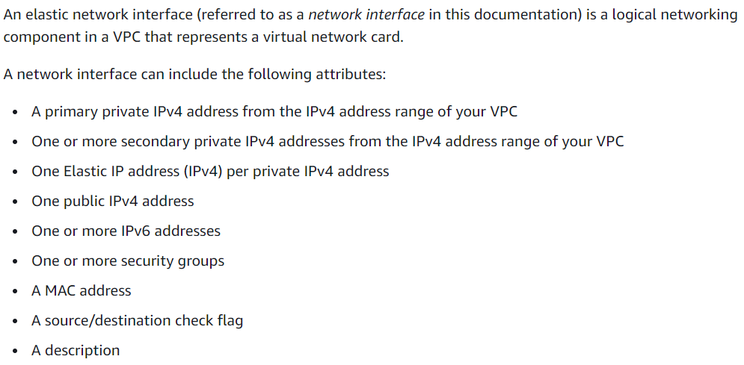

* It can have all the above
* Every ec2 instance will have primate ENI
* ENI can have one or more private IPs

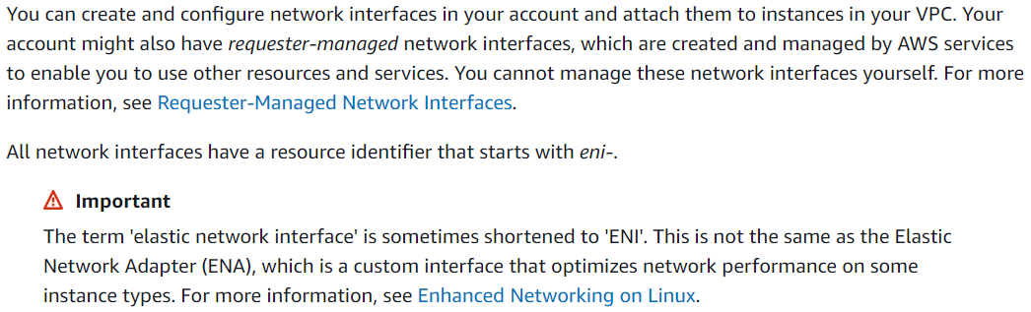

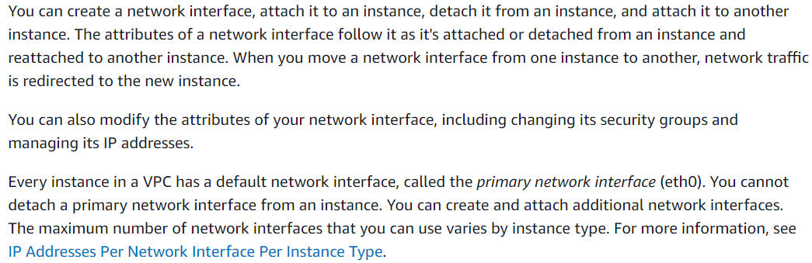

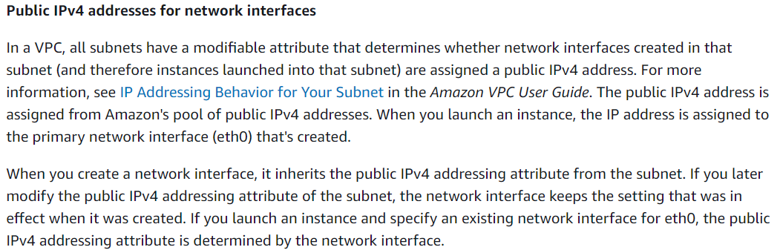

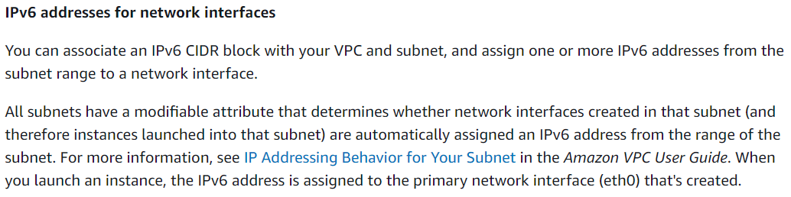

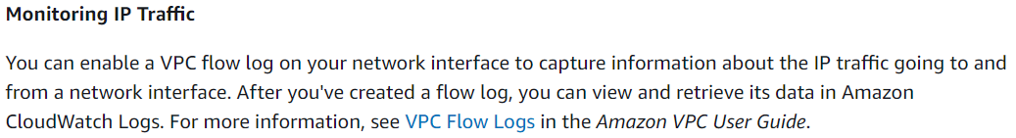



**Practical:**

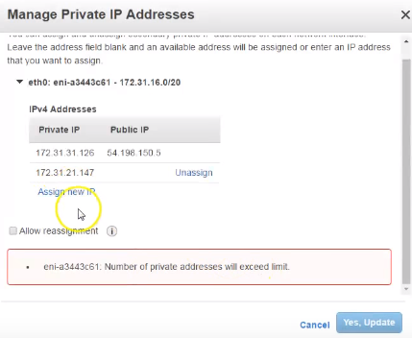

* We can assign it as above for the bigger instance. For micro it is not applicable
* The primary ENI can not be detached. If we want, we can detach the secondary one

**Create an ENI:**

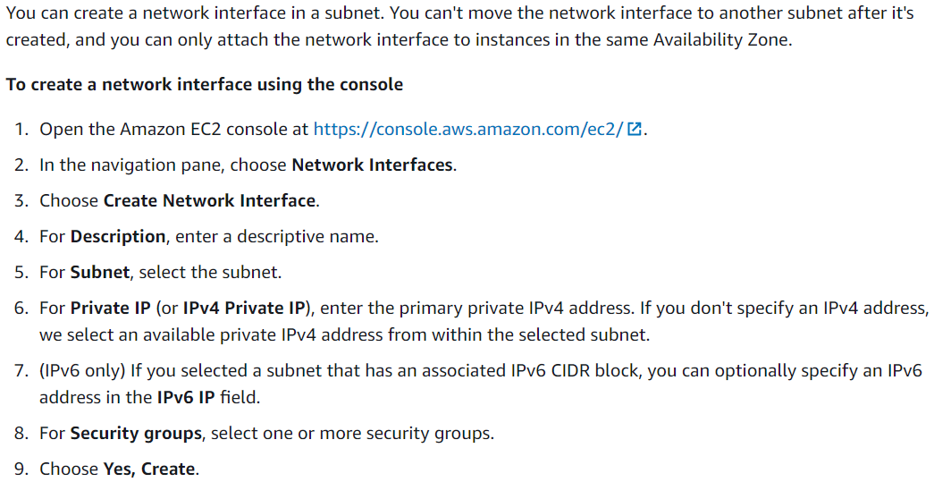

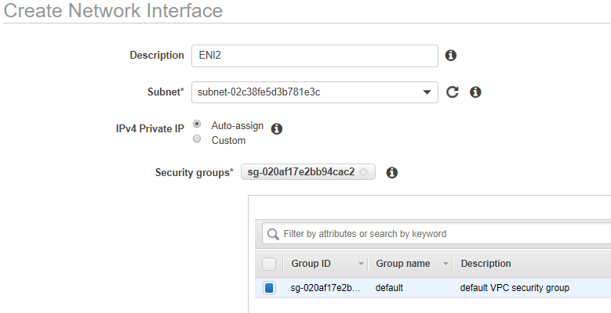

* We can create the ENI as above for any subnet with auto assign private IP or the custom one
* We also need to select the security group while creating it

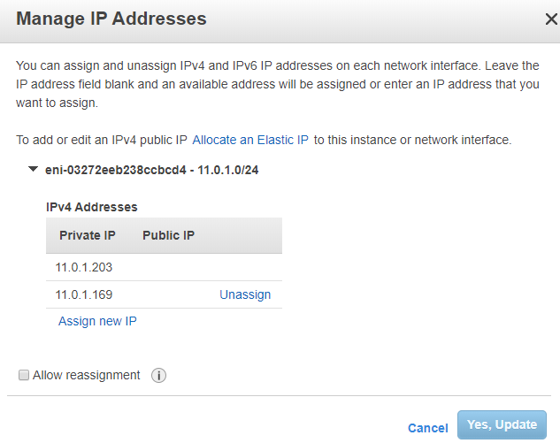

* Once the ENI created, it will have one private IP assigned to it automatically which we can remove. We can add one more if we want and remove it whenever we want
* We can select the ENI, click on actions and select “manage addresses” and then we can add new private IP to that as above
* Click on assign new IP and click on “yes,update” so that it will auto assign the IP
* If we want, we can give the custom IP and save
* **And when we assign this ENI to an instance, all the IPs that are under this ENI will be added to the instance and when we remove it from ENI, that gets removed automatically from instance, we no need to stop instance for this**
* We can also change the security group

**Attaching it to an instance:**

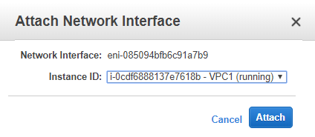

* We can attach it to an instance which is under same subnet as above

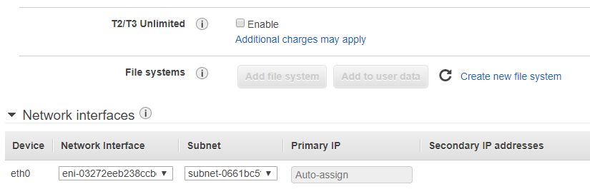

* We can also attach it while create the instance as above

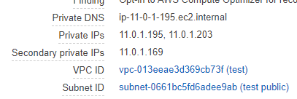

* Once we attach the ENI, we can see the instance having secondary IP as above
* **If we have selected the default ENI while creating an instance and attach the custom ENI later on, then we get both IPs attached to an instance as above and we can’t delete the default one. If we detach the ENI, then the ENI IPs will be removed but not the default one**
* **But if we select the ENI at the time of creating an instance, then we can detach it until we terminate the instance**
* We no need to stop the instance while assigning the ENI if it is secondary



* Once we have inserted, we can also see there are two ENIs

**Associate elastic IP:**

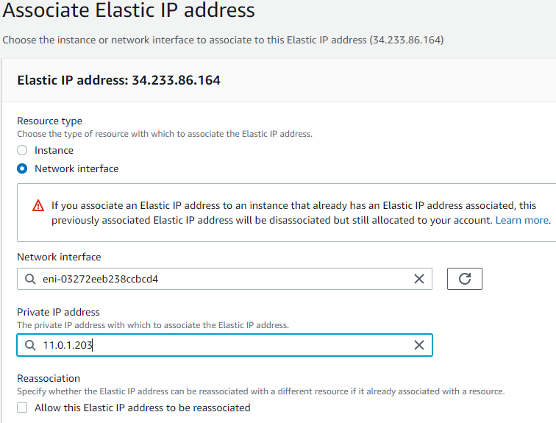

* We can assign elastic IP to the ENI and we can see the assigned IPs to the ENI
* **We cannot assign the IP to an ENI if the VPC doesn’t have any internet gateway assigned**

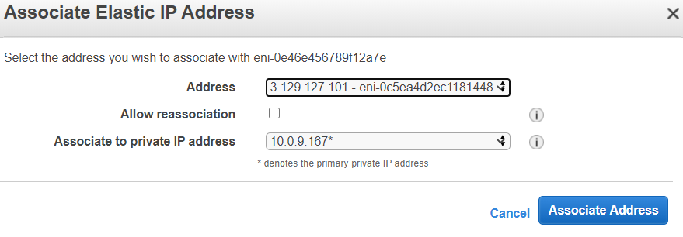

* We can also go to **ENI 🡪 actions 🡪associate address** option and select the elastic IP and the private IP to which the association is required as above.

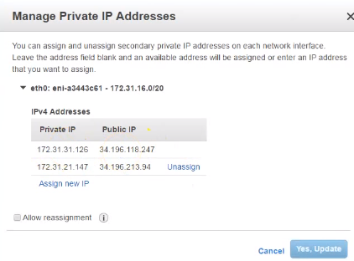

* As above, if we go to manage private address. 34.196.118.247 is the public IP per private IP 172.31.31.126
* We can change the secondary public or private IP whenever we want
* **But, if we want to change the elastic IP per private IP, we can change it in network interfaces under manage IP addresses section or we can directly assign the elastic IP to an instance and get it applied to the instance automatically**
* We can have a public or elastic IP per private IP and assign it to the instance

**In simple words, ENI just comes with all the network stuff like security groups, public and private IPs**

**But when we create it, it gets created with one private IP default, we can’t delete it. We can add a public or elastic IP to that private IP and also, we can create more public and private IPs and add it**

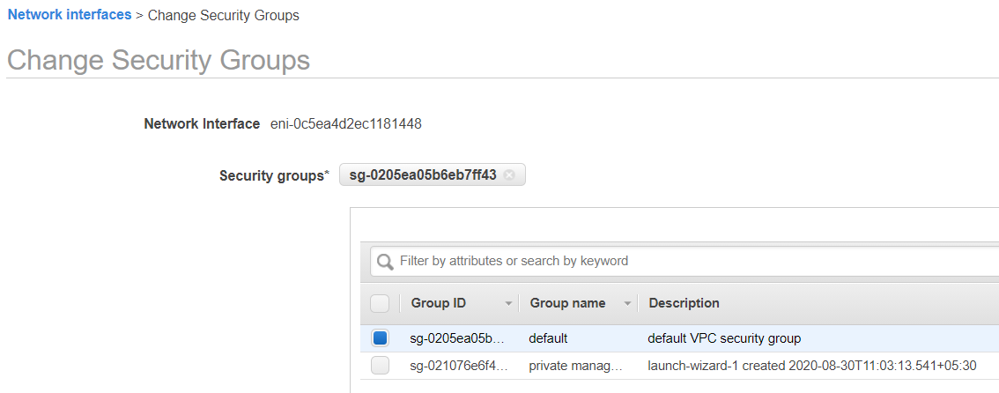

* We can also create security group and add that one to the ENI under ENI 🡪change security group option and maintain different security group for the ENI

**Delete an ENI:**

